**Lab 1 and Lab 2 Report**

**Pamela Gavojdian**

**1386733**

Lab 1:

**Exercise #3 - Setup SCADA LAB Environment**

In this exercise I can see that the water tank HMI levels are increasing when it is turned on meaning that the tank is filling up with more water. Also the Gas line levels are increasing as well when it is turned on meaning that more gas if flowing through.

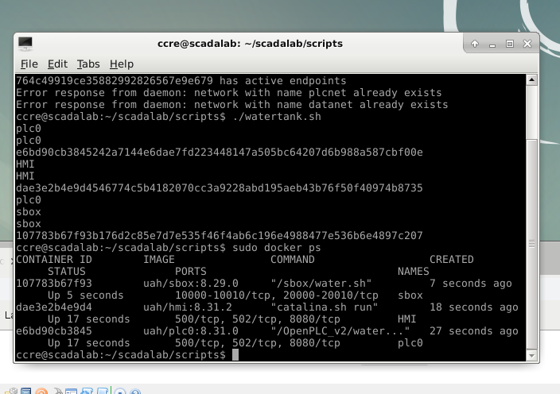

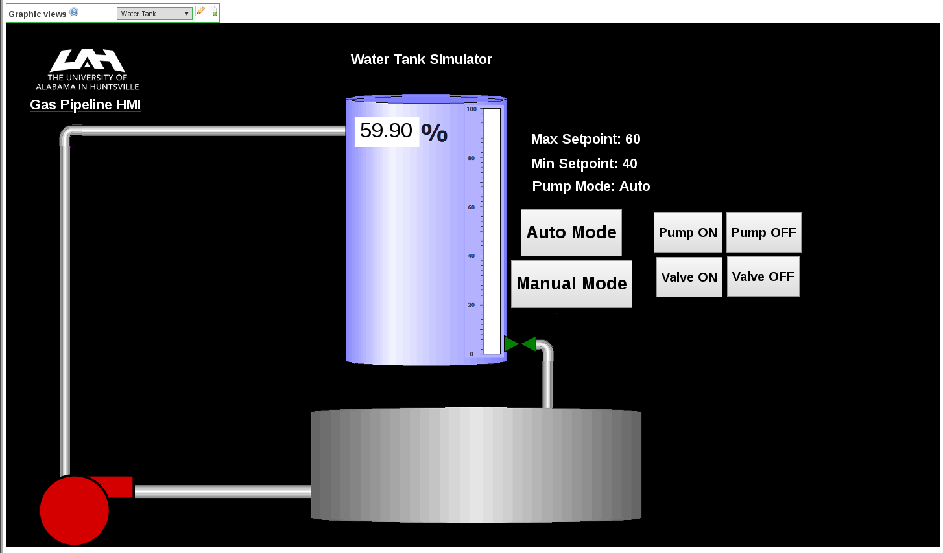

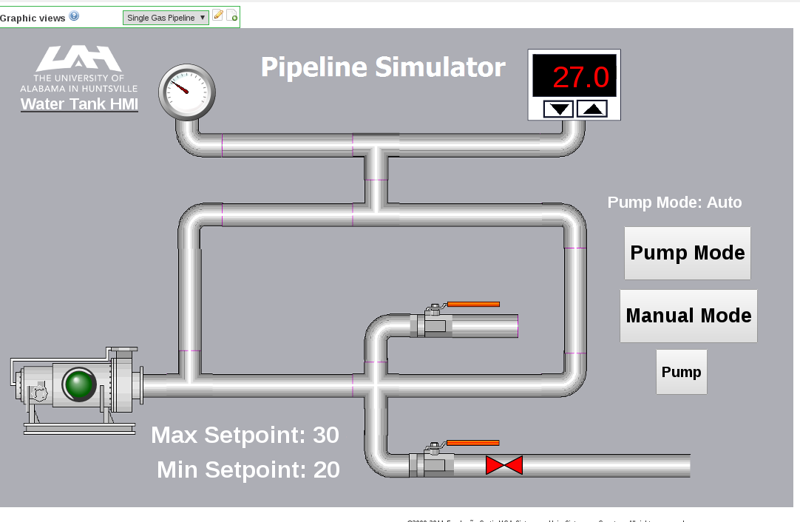

**Exercise #4 - Interact with HMI and Configure for Unsafe Operations**

When turning the manual mode on I can see that the percentage of water in the water tank is drastically increasing to the point that it is filling and the tank past the maximum capacity. Where I stopped it was 144.03% but it could have increased further. Once the pump is turned off the percentage of water that is in the tank decreases

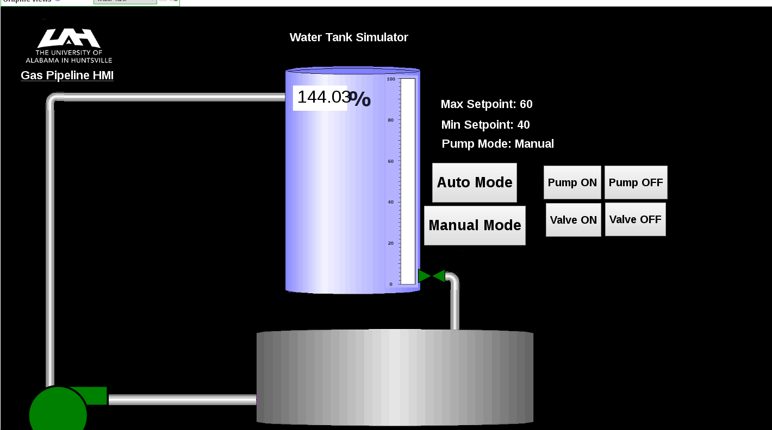

When the range in limited it takes a while for the levels to change, it doesn’t increase as fast as it did before and the same goes for decreasing.

When making the min set point higher then max set point I saw that the water levels inside the tank were staying below the min set point, which I had set as 35.0 and the max, was set at 25. It was using the min as if it was the max and did not exceeding it.

LAB 2: SCADA Control System Networking

**Exercise #3 - Introduction to Wireshark & Traffic Capture**

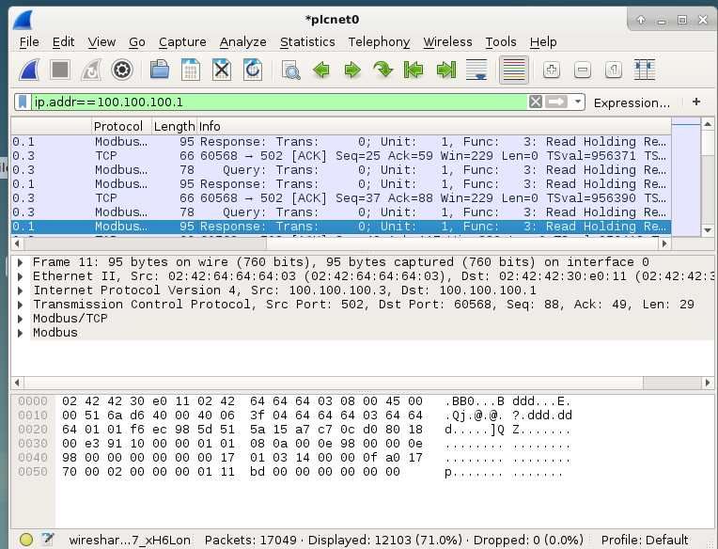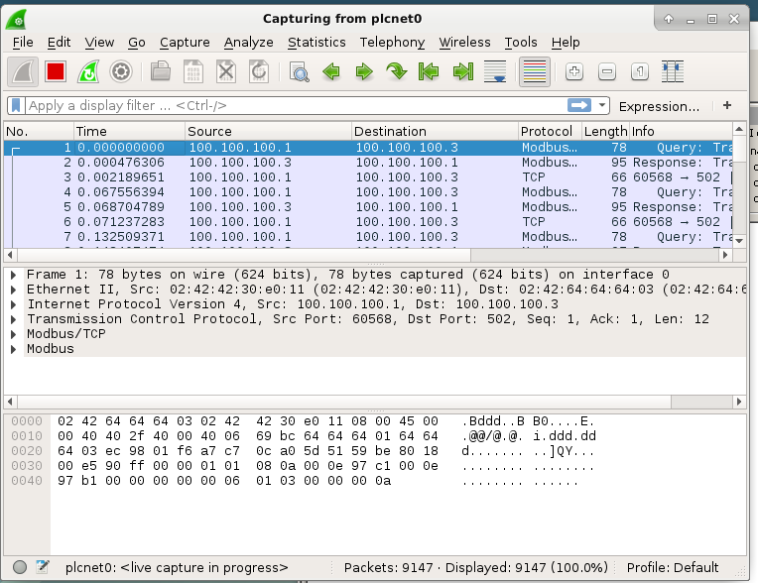

**Exercise #4 - Wireshark filters**

Below are the following filters applied to capture traffic in Wireshark. You can see in the first one that I filtered out IP addresses that are only 100.100.100.1 and 100.100.100.3.

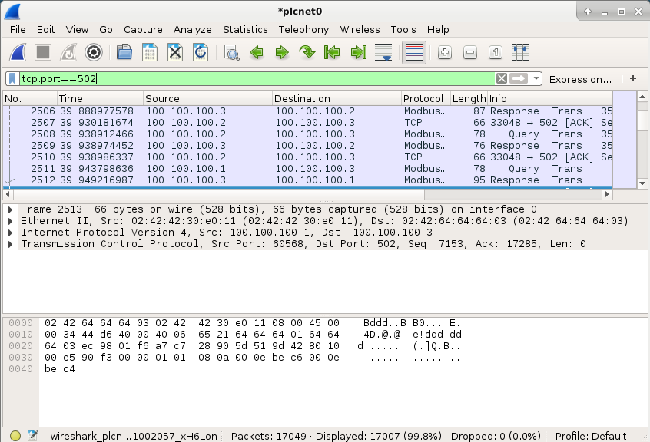

In this one I filtered out to only see traffic from HTTP ports and DNS. 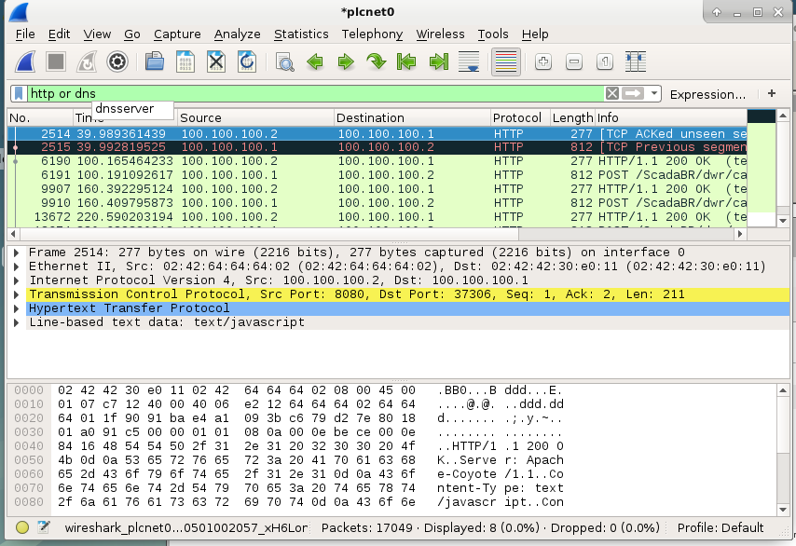

Only TCP reset flag traffic is shown. 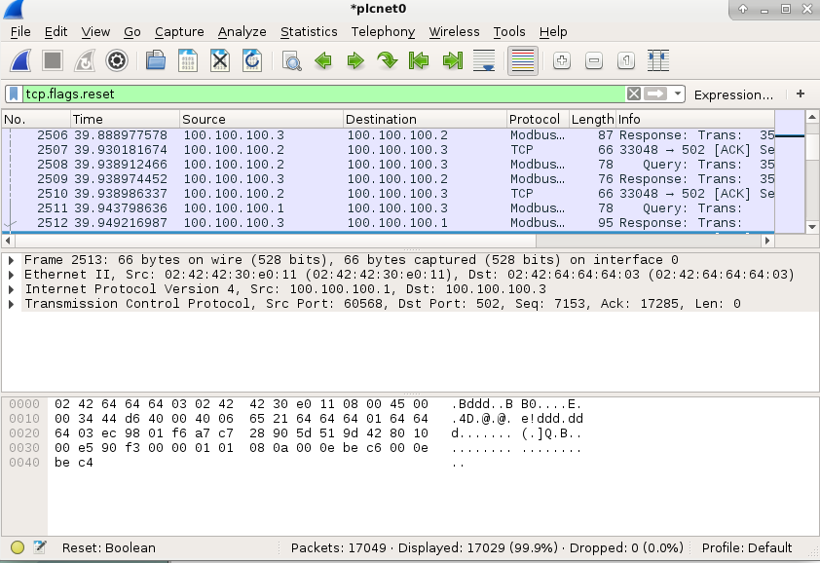

Only HTTP get requests are shown below 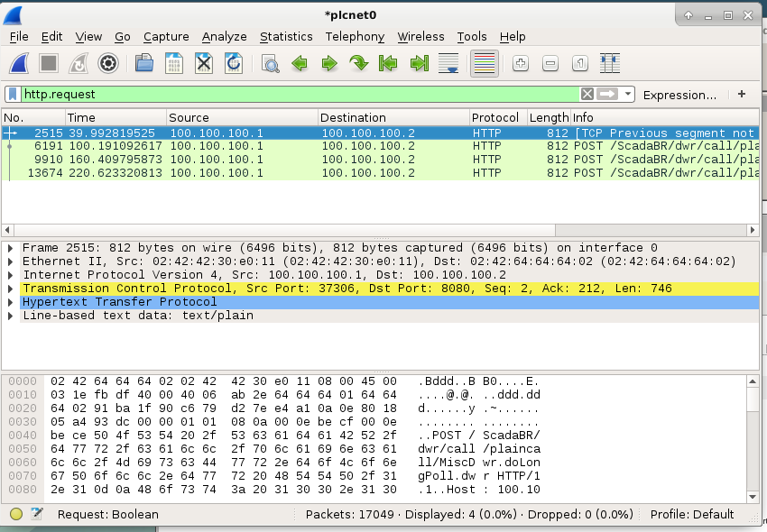

Only TCP traffic is shown below

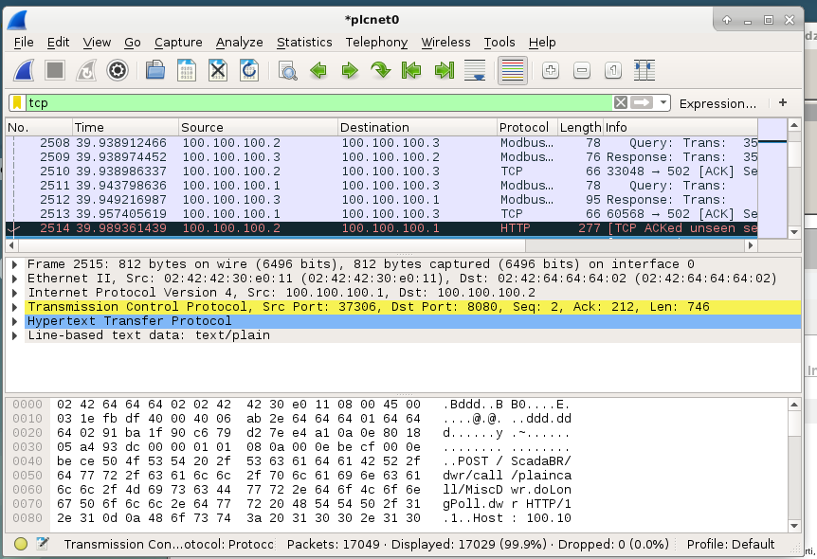

This filter removed all DNS and HTTP traffic